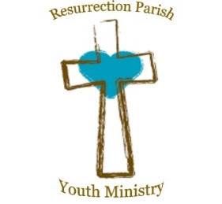
Resurrection Parish
Confirmation class schedule 2026
All classes will begin in the youth room unless otherwise noted.
Sunday, Dec. 14, 2025; 10:45 AM–12:15 PM Gathered Session 1
- Parent/Guardian AND Young person Introductory Session
- Bring electronic device to log into online modules.
- Complete Online Module 1
Online Modules 2–3 complete prior to Jan 11 class (Gathered Session2&3).
Sunday, Jan. 11, 2026; 10:45 AM–1:30 PM Gathered Sessions 2 &3
Online Modules 4–5 complete prior to January 25 (Gathered Sessions 4&5)
Sunday, January 25, 2026, 10:45 AM–1:00 PM Gathered Sessions 4&5
Sunday, Feb. 22, 2026, 9:30 AM-6:00 PM Retreat
- Attend 9:30 A.M Mass
- Complete Module 6
- Session 6
- Sacrament of Reconciliation
Online Modules 7-8 complete prior to March 8 class
Sunday, March 8, 2026 10:45 AM–1:00 PM Gathered Sessions 7&8
March 28 2026; 9:30 AM–5:15 PM Annual Diocesan Pilgrimage Parents/Sponsors attend
Sunday, April 26, 2026, 10:45 AM–3:00 PM Gathered Session 9 Sponsors attend.
- Online Module 9
- Review of the Rite of Confirmation
- Rehearsal for Reception of the Sacrament
- Gathered Session 9
- Discussion questions with Sponsor
Online Module 10 due by June 1
September 18, 2026 6:30 PM Rehearsal at Holy Family
September 19, 2026: 11:00 AM at Holy Family with Holy Family Candidates Confirmation Mass with Bishop Koenig
September 27, 5:30-6:15 (45 minutes) Gathered Session 11

Online Module Due Dates
Online Modules 2–3 Jan 11
Online Modules 4–5 January 25
Online Module 6: Sunday, Feb. 22 Complete during retreat. Bring a phone, tablet, or laptop with you to the retreat.
Online Modules 7 and 8 March 8
Online Module 9: Sunday, April 26 Complete during Gathered Session 9 with sponsors. Bring a phone, tablet, or laptop with you.
Online Module 10 due by June 1

